Prismatic Docking Buffer Lattice
White Paper Proof of Concept for Buffered Ship-to-Port Polarity Equalization and Transient Field Handoff
Document Type | Docking infrastructure proof-of-concept white paper
Concept Thesis | Use prismatic relay nodes, a balanced dual-channel corridor, and buffer sinks so ship-to-port polarity shifts and transient field mismatches are absorbed through a managed lattice instead of a single hard-contact surge.
Primary Use | Docking transient absorption, polarity equalization, buffered power handoff, and soft-start port coupling
Status | High-level concept architecture draft
Abstract
Prismatic Docking Buffer Lattice is a docking and port-infrastructure concept that treats ship entry as a field-equalization problem rather than a pure mechanical connection problem. Instead of allowing a vessel’s transient polarity mismatch, stored surface charge, or localized electromagnetic stress to strike a single docking point all at once, the system opens a prismatic relay corridor between ship and port. A dual-channel balancing path spreads and softens the transient, while buffer sinks absorb the worst of the shift before the interface transitions into normal docked power transfer or standby. In this framing, the lattice behaves less like uncontrolled arc behavior and more like a managed bleed-and-handoff surface.
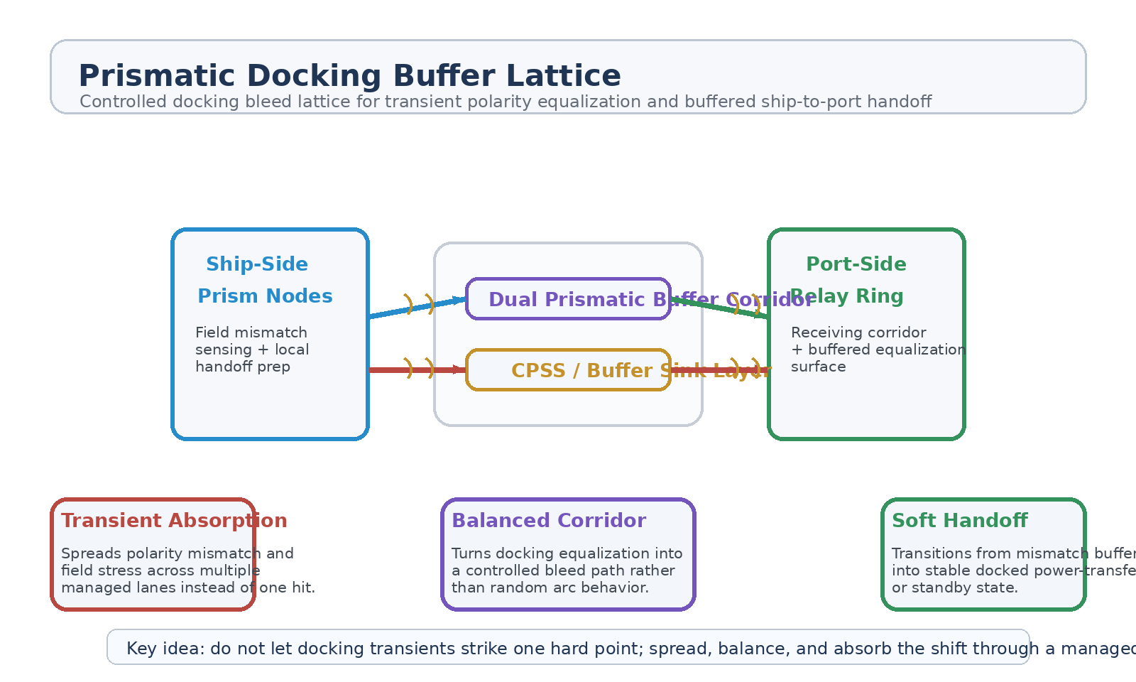
Figure 1. Ship-side prism nodes, dual prismatic buffer corridor, CPSS-like buffer sink layer, and port-side relay ring.
1. Concept Thesis
The central idea is that docking should not force a ship and port to resolve every field mismatch through one abrupt contact event. If a vessel carries uneven surface charge, residual field tension, or transient polarity offset, a direct hard coupling can create stress spikes, arc behavior, or unstable handoff conditions. A prismatic lattice offers a cleaner path: open a controlled corridor, spread the event through multiple lanes, absorb part of the mismatch through buffer sinks, and only then move into normal docked state.
This makes docking feel less like impact and more like guided equalization.
2. Why the Prismatic Lattice Fits
• Distributed prism nodes can spread incoming field stress across a wider surface.
• A dual corridor gives balancing and redundancy instead of one exposed path.
• A relay ring can behave as a receiving surface rather than a single connector pin.
• Buffer sinks can absorb or soften transient energy before normal transfer begins.
• The whole event can be sequenced as a soft-start handoff instead of an abrupt surge.
3. System Architecture
Layer | Subsystem | Primary Function | Docking Role
L1 | Ship-Side Prism Nodes | Sense mismatch, open local relay faces, and prepare the outgoing equalization path. | Source-side preparation
L2 | Dual Prismatic Buffer Corridor | Balance and distribute transient field load through paired channels. | Managed bleed path
L3 | CPSS / Buffer Sink Layer | Absorb, smooth, or store part of the transient during equalization. | Shock absorption
L4 | Port Relay Ring | Receives and spreads the handoff across a broader docking surface. | Receiving equalization surface
L5 | Docked Utility State | Transitions into normal transfer or standby once mismatch is reduced. | Stable port coupling

3.1 Ship-Side Prism Preparation
Before hard coupling, the vessel-side prism nodes act as mismatch sensors and local launch points for the equalization event. Their role is to turn a potentially chaotic transient into a structured handoff aligned with the corridor instead of a free arc across one contact location.
3.2 Dual Buffer Corridor
The dual prismatic corridor is the key architectural upgrade. One lane does not have to carry the whole event. Instead, the paired channel can balance, spread, and reinforce the equalization process, making the handoff more stable than a single-lane path.
3.3 Buffer Sink Behavior
A CPSS-like sink or equivalent buffer module sits behind the receiving architecture so the port does not need to reflect or dump the entire transient immediately. This gives the system somewhere for the mismatch to go while the field state settles toward a usable docked condition.
3.4 Soft-Start Docking State
Once the shift is reduced, the system transitions to a normal docked state. At that point the lattice is no longer primarily absorbing mismatch; it becomes a routing and utility-support layer for conventional port behavior or standby monitoring.
4. Mission Roles
• Docking transient absorption during ship arrival.
• Polarity equalization before hard power or utility coupling.
• Buffered power-transfer handoff between ship and port.
• Soft-start loading for vessels with high stored field or surface charge.
• Emergency bleed path when damaged ships arrive with unstable energy states.
5. Why This Is Stronger Than a Single Hard Contact
• Spreads the event instead of concentrating it at one vulnerable point.
• Allows the port to receive through a surface or ring rather than a pin-like contact.
• Supports smoother sequencing from mismatch to utility state.
• Reduces the conceptual likelihood of abrupt surge behavior at first contact.
• Fits naturally with distributed relay and field-balancing doctrines already present in the broader prismatic system family.
6. Boundaries and Realism
This concept is strongest as a field-equalization and docking-buffer architecture. It should not be oversold as uncontrolled 'chain lightning' used as a universal transfer medium. The more coherent story is disciplined plasma or electromagnetic bleed control, spread across a managed lattice and paired corridor. Its value is not visual drama. Its value is softening and sequencing a high-stress docking event.
• Most credible for transient handling, polarity equalization, and buffered handoff.
• Best understood as a docking support lattice rather than a general replacement for all hard infrastructure.
• Relies on managed routing and buffer sinks, not chaotic free arcing.
• Works best where the port already has distributed relay surfaces or receiving rings.
7. Proof-of-Concept Build Path
Phase | Goal | Bench / Program Activity | Success Signal
P1 | Mismatch baseline | Characterize a controlled docking-style transient with single-point coupling. | Reference spike profile
P2 | Prism-node handoff | Add source and receiving relay surfaces with staged corridor opening. | Structured equalization path
P3 | Dual-corridor test | Introduce paired lanes and compare load spread against a one-lane baseline. | Improved balancing
P4 | Buffer sink integration | Place a CPSS-like sink behind the receiving ring and evaluate transient absorption. | Reduced peak stress
P5 | Soft-start transition | Sequence from equalization mode into stable transfer or standby. | Clean docked-state handoff

8. Conclusion
Prismatic Docking Buffer Lattice reframes docking as a field-management event instead of a single hard-contact event. Prism nodes on the ship side prepare the handoff, a dual corridor balances the transient, and buffer sinks give the mismatch somewhere to go before normal port behavior begins.
As a white paper PoC, the concept is best understood as a controlled docking bleed lattice: not random lightning, but a disciplined equalization surface that turns violent first contact into a managed, buffered transition.
Working one-line doctrine: Do not let docking transients strike one hard point; spread, balance, and absorb the shift through a managed prismatic lattice.

